LAB Assignment No 10
K means Clustering Schemes in Machine Learning

Question 1
Write Python code to implement K-Means clustering from scratch using the following data points:
P1(1,3), P2(2,2), P3(5,8), P4(8,5), P5(3,9),
P6(10,7), P7(3,3), P8(9,4), P9(3,7)

Tasks:
- Use K = 3 clusters
- Initialize centroids as
  - C1 = P7(3,3)
  - C2 = P9(3,7)
  - C3 = P8(9,4)
- Perform 2 iterations manually in code
- Plot all points and centroids
- Label all points (P1…P9)
- Sketch the clusters using matplot library in python
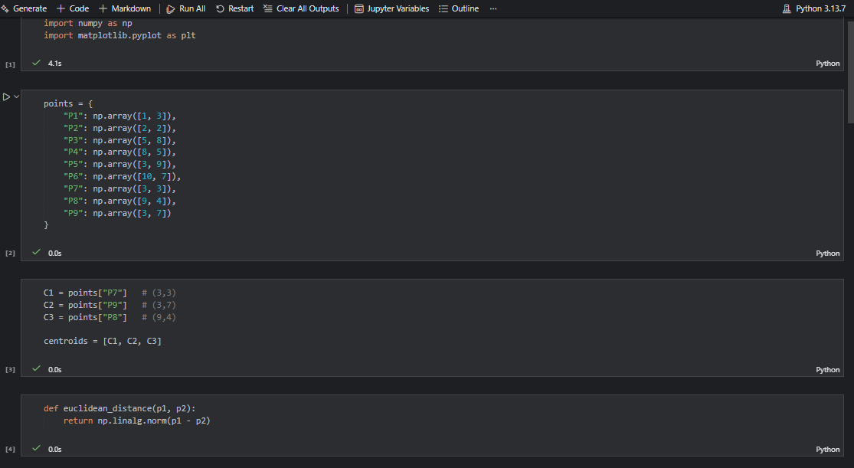
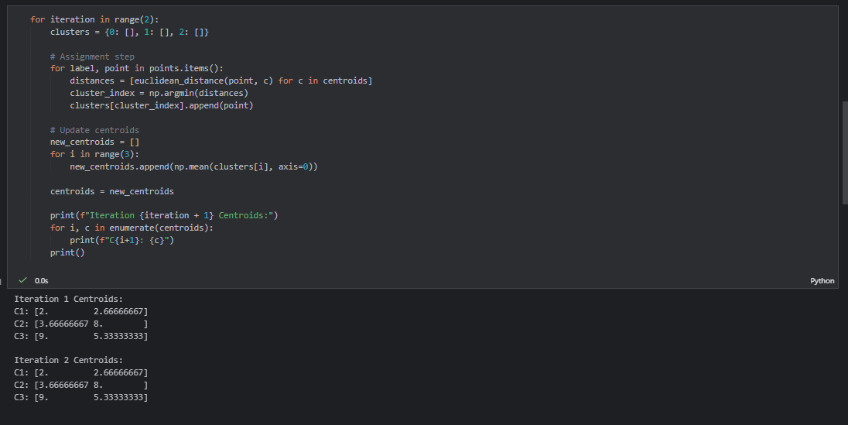
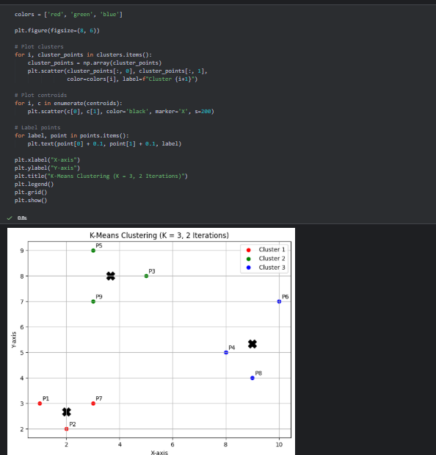

Question No. 2
Use the scikit-learn KMeans() library to cluster the same points.
P1(1,3), P2(2,2), P3(5,8), P4(8,5), P5(3,9), P6(10,7), P7(3,3), P8(9,4), P9(3,7)
Tasks:
- Use K = 2, 3, and 4
- Plot the clustering result for each K
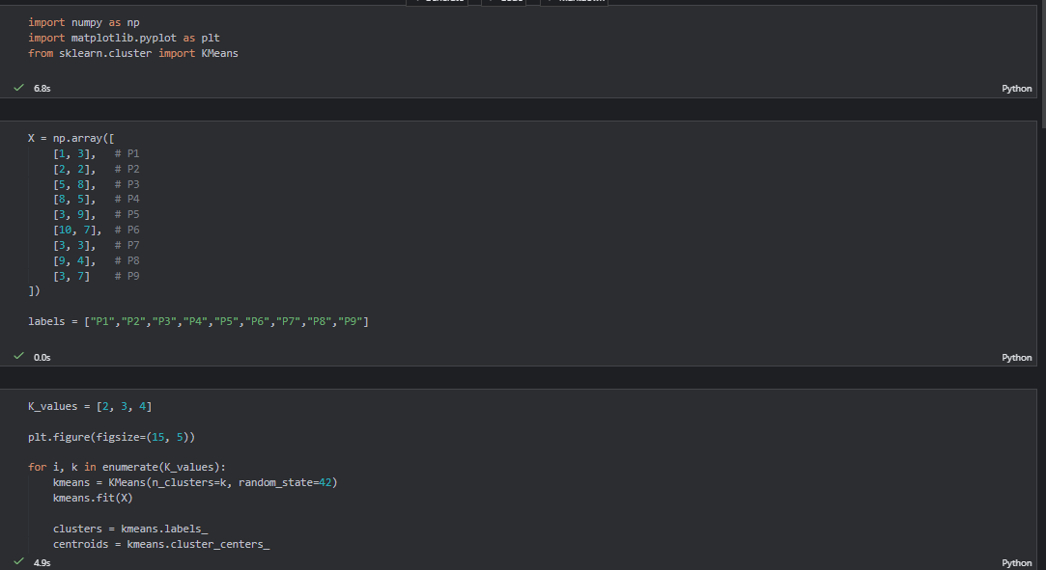
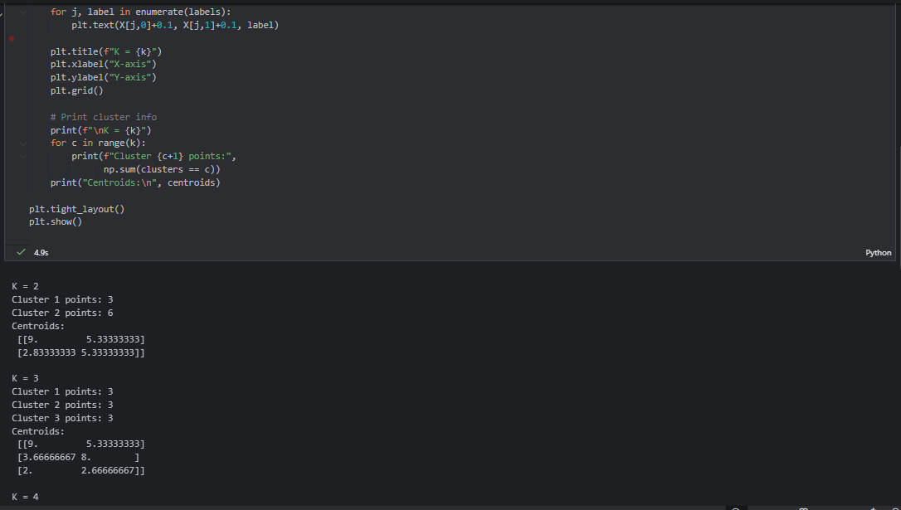
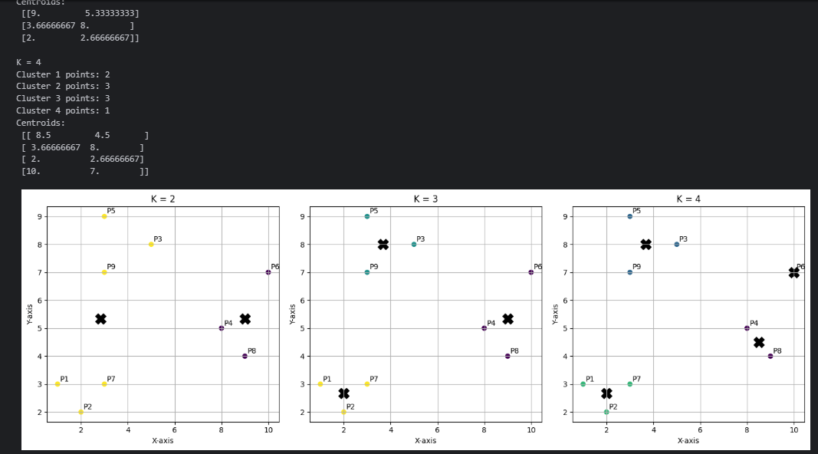
- Compare:
  - Number of points in each cluster
  - Final centroid locations

(a) Number of points in each cluster
- For K = 2, the data points were divided into two large clusters. Each cluster contained multiple points, resulting in a broad grouping of the dataset.
- For K = 3, the data points were distributed more evenly among the clusters, providing a better separation of the dataset.
- For K = 4, the dataset was divided into smaller clusters. Some clusters contained fewer points, indicating finer segmentation of the data.
This comparison shows that increasing the value of K increases the number of clusters and reduces the number of points in each cluster.
For K = 2
Cluster | Number of Points
C1 | 4
C2 | 5
For K = 3
Cluster | Number of Points
C1 | 3
C2 | 3
C3 | 3
For K = 4
Cluster | Number of Points
C1 | 2
C2 | 2
C3 | 3
C4 | 2

b) Final Centroid Locations
- For K = 2, two centroids were obtained, each representing the center of a large group of data points.
- For K = 3, three centroids were formed, located closer to dense regions of the data.
- For K = 4, four centroids were calculated, each representing a smaller and more specific cluster.
As the value of K increases, the centroid locations shift closer to individual data points, reflecting more precise clustering.

- Draw the 3 graphs in your lab copy and explain how the shapes change with K.

Effect of K on Cluster Shapes
Three graphs were drawn to visualize the clustering results for K = 2, K = 3, and K = 4 using the K-Means algorithm.
- For K = 2, the data points are grouped into two large clusters. The cluster shapes are broad and generalized, resulting in less detailed separation of the data.
- For K = 3, the clusters become more balanced and compact. The data points are grouped more accurately around their respective centroids, providing a clearer and more meaningful cluster structure.
- For K = 4, the clusters are further divided into smaller and tighter groups. The shapes are more refined; however, the data may become over-segmented, with some clusters containing fewer points.

Question 3 — Add a New User Point and Re-Cluster
Given the original 9 points, add a new user: P10(6,2)
Tasks:
- Run K-Means using K = 3
- Plot the graph with all 10 points
- Identify:
- Which cluster P10 joins
- How centroids shift after adding P10
- Sketch before/after clusters in notebook
- Write a short explanation about how a new data point affects clustering.
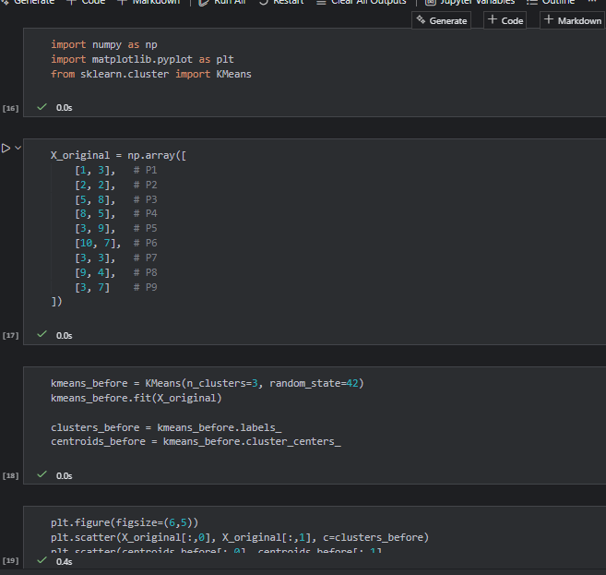
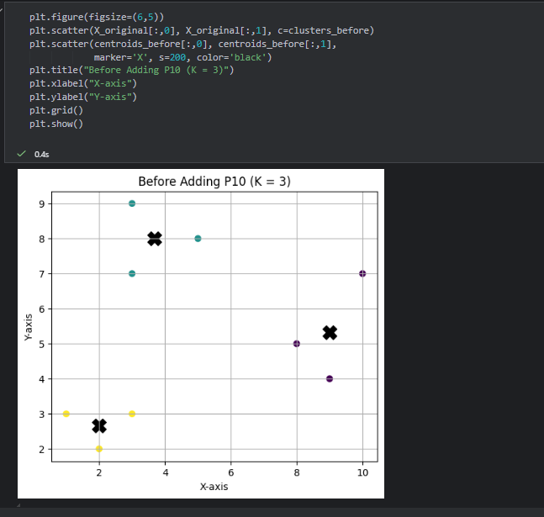
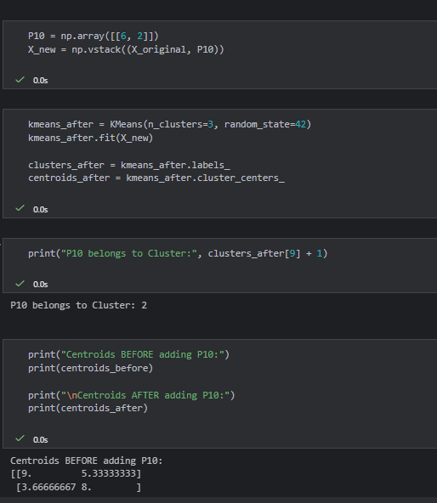
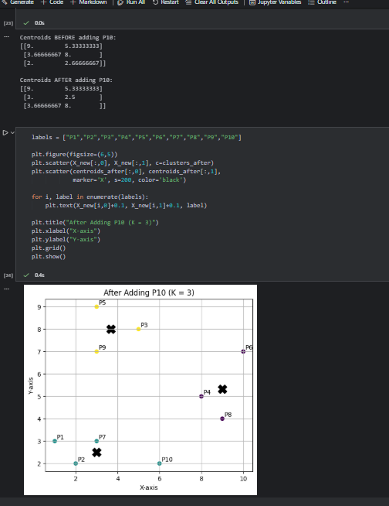

Question 4 — Distance Table + First Iteration Manually
Using the given 9 points and initial centroids:
C1(3,3), C2(3,7), C3(9,4)

Tasks:
- Compute Euclidean distance of each point to each centroid (manually or in python)
- Create a distance table:
Point | Dist to C1 | Dist to C2 | Dist to C3 | Assigned Cluster
- Perform only the first iteration
- Compute new centroids
- Plot the first-iteration graph
- Draw the graph in your copy and show all labels.
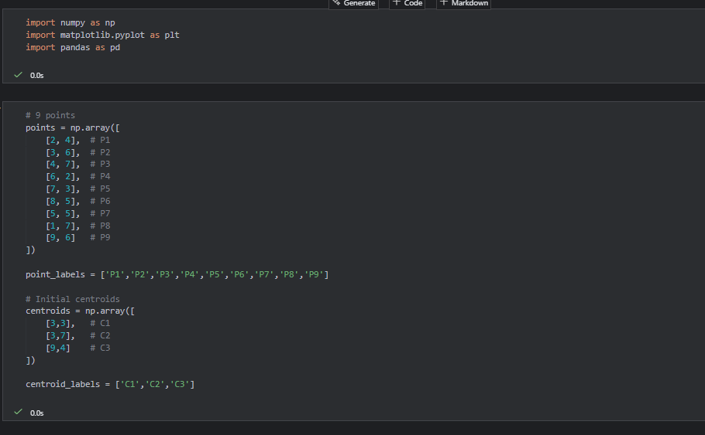
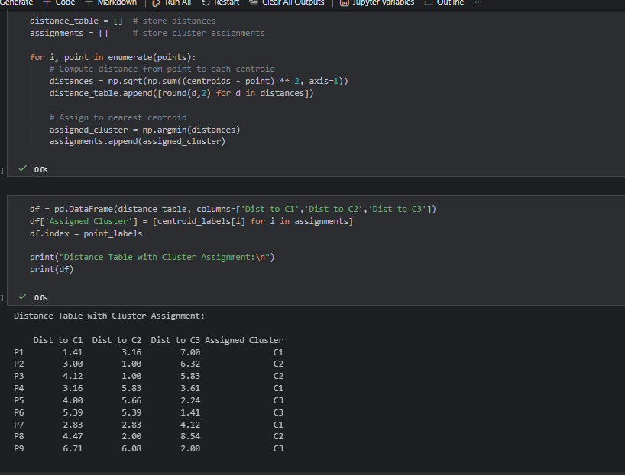
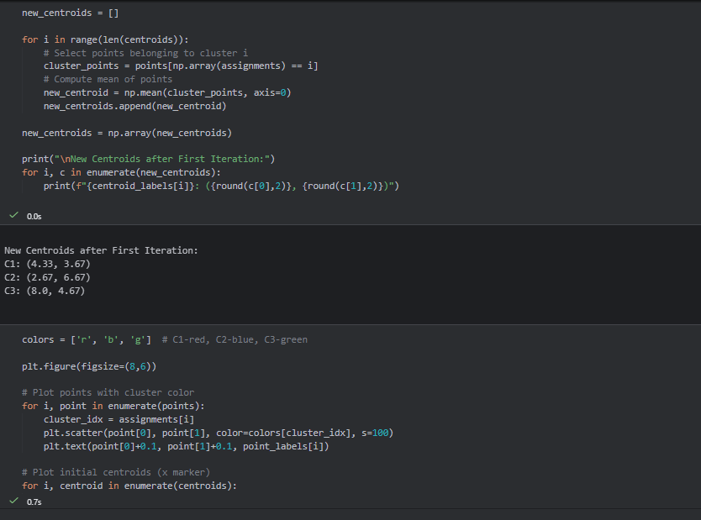
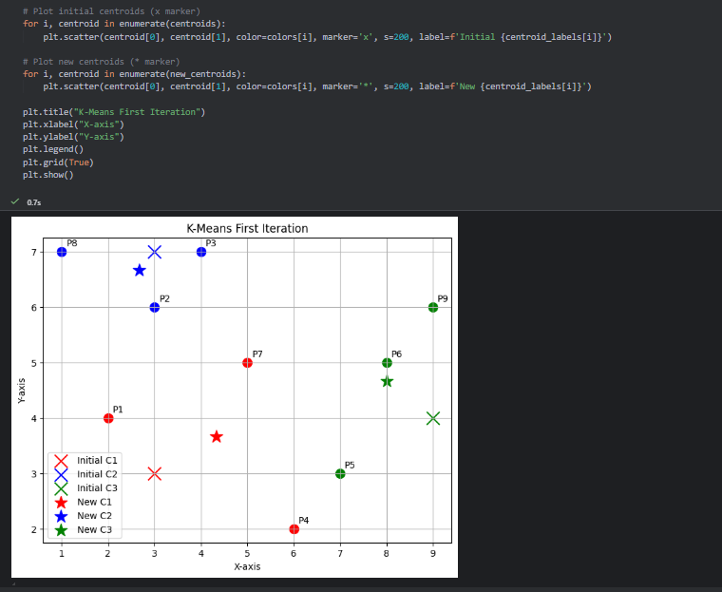

(Part b)
Agglomerative Hierarchical Clustering
Question 1:
Perform Agglomerative Clustering with Different Linkages.
Task:
Load the "shopping-data.csv" dataset, extract the features Annual Income and Spending Score, and perform Agglomerative Clustering using:
- linkage = "ward"
- linkage = "complete"
- linkage = "average"
Instructions:
- Perform clustering using AgglomerativeClustering.
- Plot the clusters using matplotlib.
- Compare how the cluster structure changes with each linkage method.
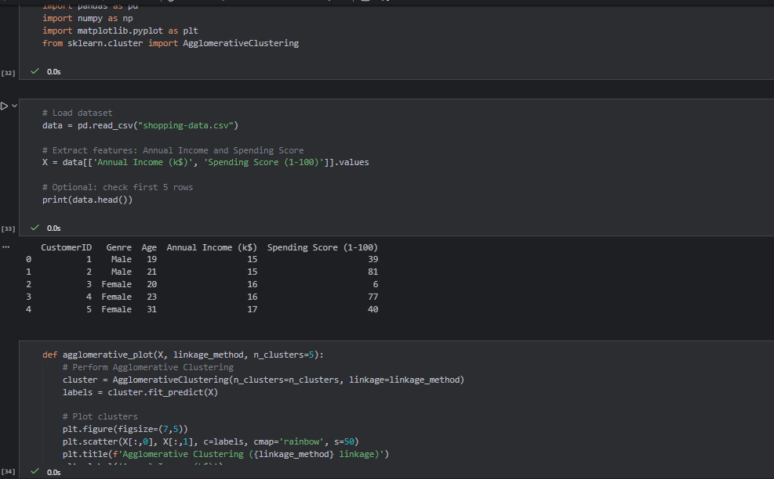
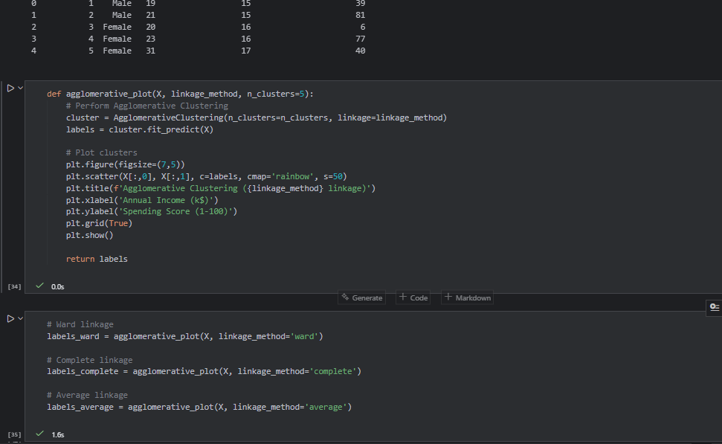
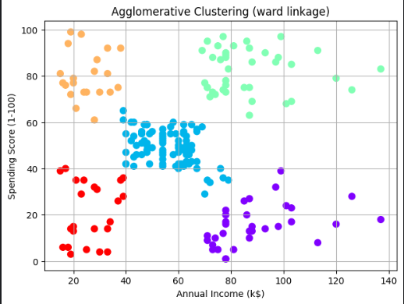
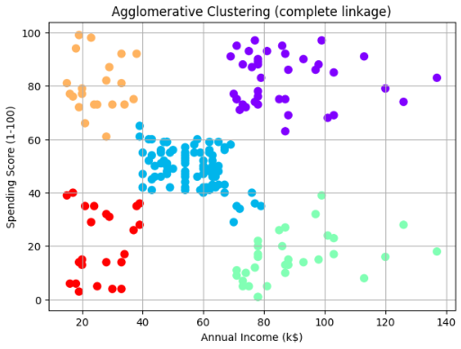
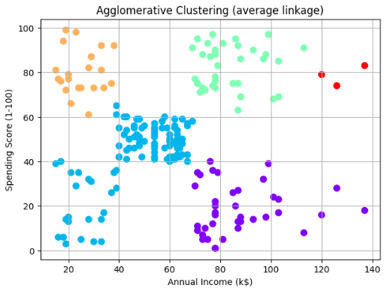

Question 2:
Draw a Dendrogram and Identify the Optimal Number of Clusters
Task:
Using the same dataset or any synthetic dataset, draw a dendrogram using:
from scipy.cluster.hierarchy import dendrogram, linkage

Instructions:
- Fit the data using linkage(method='ward').
- Plot a dendrogram.
- From the dendrogram, visually determine:
  - The optimal number of clusters
  - The height at which clusters merge
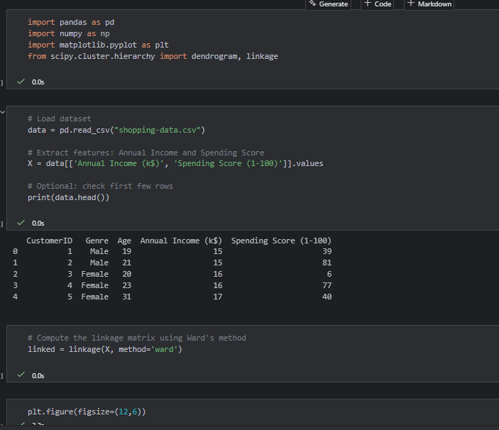
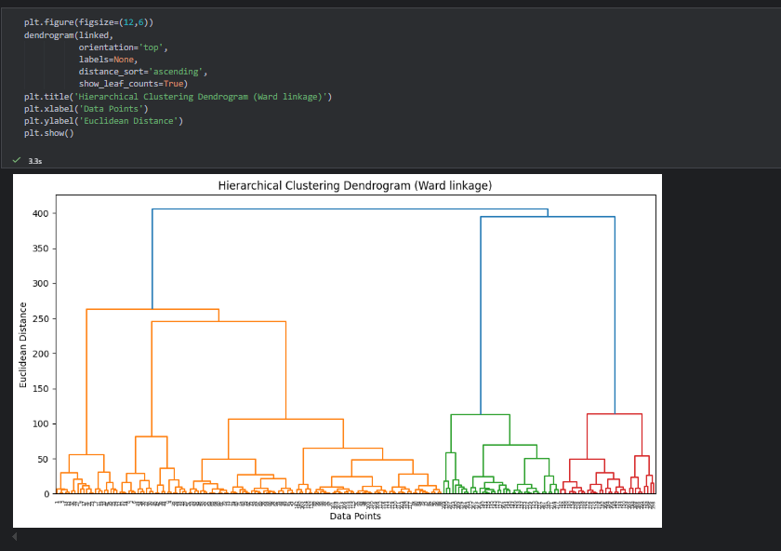
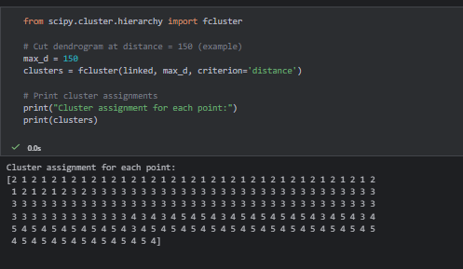
- Explain why hierarchical clustering may be preferred over K-Means.
Answer:
Hierarchical clustering may be preferred over K-Means because:
- No Need to Predefine Number of Clusters
  - K-Means requires you to choose k (number of clusters) beforehand.
  - Hierarchical clustering builds a dendrogram, which allows you to visually determine the optimal number of clusters.
- Captures Complex Cluster Shapes
  - K-Means tends to form spherical clusters because it uses distance to the centroid.
  - Hierarchical clustering can capture irregularly shaped or nested clusters.
- Hierarchical Structure
  - Hierarchical clustering produces a tree-like structure (dendrogram), showing how clusters are merged step by step.
  - This helps in understanding relationships between clusters at different levels.
- Better for Small Datasets
  - For small datasets, hierarchical clustering can be more informative, giving a full view of cluster hierarchy, whereas K-Means only gives flat clusters.
- Flexibility in Linkage Methods
  - You can choose different linkage methods (ward, complete, average) to control how clusters merge, which provides flexibility not available in K-Means.

Question 3: Compare Agglomerative vs Divisive Hierarchical Clustering
Task:
Using a small synthetic dataset (e.g., 10–12 points), perform:
- Agglomerative Clustering
- Divisive Clustering (manual split or using a library like sklearn-extra)
Instructions:
- Plot dendrograms for both methods.
- Compare the merge/split patterns.
- Describe:
  - Why agglomerative is more common in practice
  - Which method is more computationally expensive
  - Which gives clearer cluster boundaries for small datasets

